CareerWay - Business Model Canvas

1. Key Partners
• Ed-tech platforms (Udemy, Coursera, UpGrad) – Integration of online courses and certifications.
• Universities & Career Counselors – Collaboration for student mentorship.
• Job portals (LinkedIn, Internshala, Indeed) – Integration of internships and job listings.
•Schools & Coaching Centers – Adoption of CareerWay as a career counseling tool.

2. Key Activities
• AI chatbot development– Building and training AI models for personalized career guidance.
• Gamified career exploration – Developing interactive 2D mini-games for different careers.
• Scholarship & job market tracking – Real-time aggregation of funding and employment opportunities.
• Marketing & user acquisition – Expanding user base through digital campaigns and educational tie-ups.

3. Revenue Streams
• Freemium Model:Free career guidance; advanced features available via subscription ($5-$10/month).
• Affiliate Marketing:Commissions from course providers (Udemy, Coursera, universities).
• Ad-based Revenue: Universities and job platforms pay for targeted advertisements.
• Corporate Partnerships: CareerWay partners with companies for talent recruitment programs.
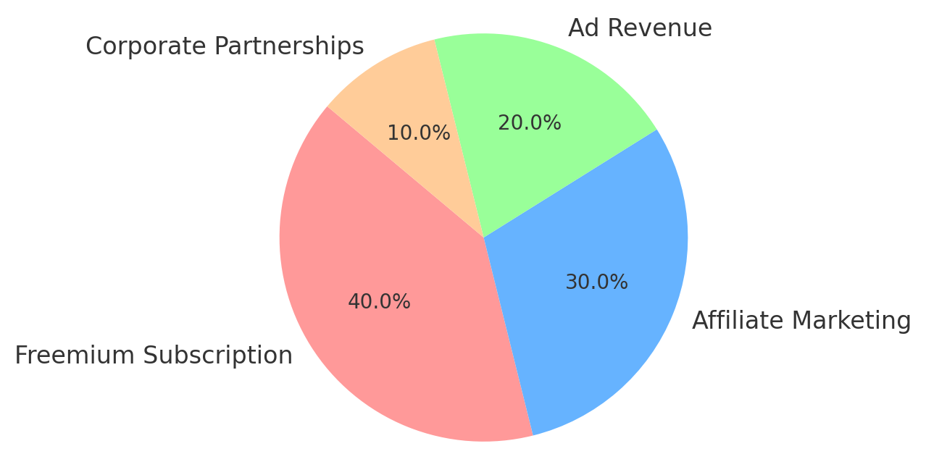
Pie Chart: CareerWay Revenue Model Breakdown

4. Cost Structure
• AI Development & Cloud Hosting– Infrastructure and ML model training costs.
• Marketing & Sales – Customer acquisition through social media and school collaborations.
• Content & Game Development– Building career mini-games and educational content.
• Operational Costs – Team salaries, support services, and partnerships.

5. Customer Segments & Value Proposition
• Students (high school & college)– Career discovery and planning.
• Parents & teachers – Tools to help guide students effectively.
• Ed-tech platforms & universities– Career roadmap and mentorship solutions.
• Value Proposition:
- AI-driven career guidance tailored to each student.
- Hands-on career experience through gamification.
- Scholarships & internships to make career paths accessible.

